Harris Academy

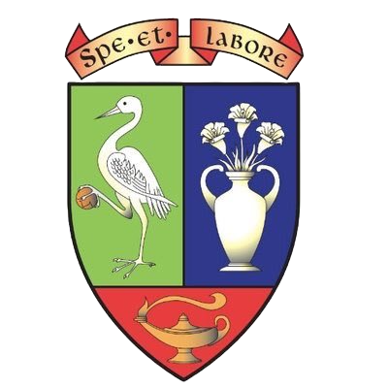

Curriculum Rationale
  - Revised December 2024 to be revised August 2025

Contents
Curriculum Rationale 3
Curriculum Model 5
The Curriculum 6
The Curriculum: Broad General Education 7
The Curriculum: Senior Phase 9
Harris Pledge 10
Digital skills 10
Inter-disciplinary learning (IDL). 11
Next Steps 12

Curriculum Rationale
Our school aim: At Harris Academy we strive to build a learning community where staff, pupils and families work together to successfully nurture and develop the potential for all.
Our values that underpin our vision are Respect, Equality, Enjoyment and Achievement.
Our curriculum:
- is driven by our school vision and values
- has personalisation, choice and challenge
- has flexibility to support all young people ensuring equality for all
- is coherent and progressive from 3 to 18 which enables our young people to continue to develop the four capacities and obtain qualifications
- enables our young people to receive support to reach their full potential
- equips our young people with the knowledge and skills that will lead to a positive and sustained destination
- ensures skills for learning, skills for life and skills for work with a continuous focus on literacy and numeracy and health and wellbeing
- includes our Harris Pledge which compliments academic achievement by ensuring a wide range of opportunities for all including leadership, volunteering, career enrichment and wider experiences.
Cognisance has been taken of our local and national vision statements:
DCC Vision
“Our vision is the delivery of a quality educational experience in which all children and young people aspire to reach the highest personal levels of attainment and achievement.”
Dundee City Council – Children and Families Service

National Improvement Framework Vision
“Our vision is: Excellence through raising attainment: ensuring that every child achieves the highest standards in literacy and numeracy (set out within Curriculum for Excellence levels) and the right range of skills, qualifications and achievements to allow them to succeed; and Achieving equity: ensuring every child has the same opportunity to succeed with a particular focus on the poverty-related attainment gap.”
Scottish Government National Improvement Framework (Jan 2016)

Our goal is to improve the life chances of all our young people, working in partnership with parents, carers, partners, employers and the wider community. We also have a supportive Parent/Carer Voice that provides a vehicle for strong and effective partnership with our parents and carers.
The school is fully committed to meeting the needs of all young people and to providing a wide range of learning opportunities for all members of our school community. Within a climate of Every Dundee Learner Matters, through Participation, Progress and Presence we aim to raise attainment, achievement and ambition of all children and young people. within a climate of Every Dundee Learner Matters. Supporting young people with their learning is the core responsibility of all members of staff. At the heart of everything that we do is facilitating the development of the four capacities of Curriculum for Excellence for every young person.

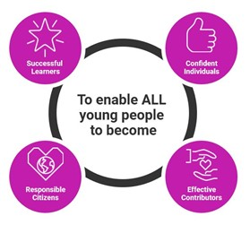

Curriculum Model
Our school operates a thirty-three-period week model. This is currently under review.
Broad General Education
 | Monday | Tuesday | Wednesday |  | Thursday | Friday
Period 1 | 8:40 - 9:35 | 8:40 - 9:35 | 8:40 - 9:35 | Period 1 | 8:40 - 9:35 | 8:40 - 9:35
Period 2 | 9:35 - 10:25 | 9:35 - 10:25 | 9:35 - 10:25 | Period 2 | 9:35 - 10:25 | 9:35 - 10:25
Break | 10:25 - 10:40 |  |  | Break | 10:25 - 10:40
Period 3 | 10:40 - 11:30 | 10:40 - 11:30 | 10:40 - 11:30 | Period 3 | 10:40 - 11:30 | 10:40 - 11:30
Period 4 | 11:30 - 12:20 | 11:30 - 12:20 | 11:30 - 12:20 | Period 4 | 11:30 - 12:20 | 11:30 - 12:20
Period 5 | 12:20 - 13:10 | 12:20 - 13:10 | 12:20 - 13:10 | Lunch | 12:20 - 13:10
Lunch | 13:10 – 14:00 |  |  | Period 5 | 13:10 - 14:00 | 13:10 - 14:00
Period 6 | 14:00 - 14:50 | 14:00 - 14:50 | 14:00 - 14:50 | Period 6 | 14:00 - 14:50 | 14:00 - 14:50
Period 7 | 14:50 - 15:40 | 14:50 - 15:40 | 14:50 - 15:40
Senior Phase
 | Monday | Tuesday | Wednesday |  | Thursday | Friday
Period 1 | 8:40 - 9:35 | 8:40 - 9:35 | 8:40 - 9:35 | Period 1 | 8:40 - 9:35 | 8:40 - 9:35
Period 2 | 9:35 - 10:25 | 9:35 - 10:25 | 9:35 - 10:25 | Period 2 | 9:35 - 10:25 | 9:35 - 10:25
Period 3 | 10:25 - 11:15 | 10:25 - 11:15 | 10:25 - 11:15 | Period 3 | 10:25 - 11:15 | 10:25 - 11:15
Break | 11:15 - 11:30 |  |  | Break | 11:15 - 11:30
Period 4 | 11:30 - 12:20 | 11:30 - 12:20 | 11:30 - 12:20 | Period 4 | 11:30 - 12:20 | 11:30 - 12:20
Period 5 | 12:20 - 13:10 | 12:20 - 13:10 | 12:20 - 13:10 | Lunch | 12:20 - 13:10
Lunch | 13:10 – 14:00 |  |  | Period 5 | 13:10 - 14:00 | 13:10 - 14:00
Period 6 | 14:00 - 14:50 | 14:00 - 14:50 | 14:00 - 14:50 | Period 6 | 14:00 - 14:50 | 14:00 - 14:50
Period 7 | 14:50 - 15:40 | 14:50 - 15:40 | 14:50 - 15:40

The Curriculum
The flexibility of our curriculum is enhanced by the strategic partnership created by Dundee City Council including but not limited to Dundee and Angus College, Al-Maktoum College, Employers, Universities, City Campus and Community Learning and Development Teams. This ensures collaborative work has positive outcomes for our young people. This partnership enhances our curriculum offer and provides progressive learner pathways.
For bilingual young people, their curriculum may include planned experiences/courses in developing their knowledge, skills and understanding of English through ESOL. The Bilingual Pupils’ Support Service (BPSS) works in partnership with Harris and provides our young people to have an individualised learning pathway.
For young people with a hearing or visual impairment, flexibility in the curriculum may include planned experiences and programmes for learning in either British Sign Language (BSL) or use of alternative communication methods such as braille. Harris works in partnership with the Accessibility and Inclusion Service. (AIS).

The Curriculum: Broad General Education
S1-S3 Our curriculum is designed to embrace the principles of Curriculum for Excellence (CfE). There are opportunities for young people to make choices of subjects and courses at key stages. Our BGE curriculum has been designed around the CfE experiences and outcomes up to and including the fourth level, in each of the eight curricular areas of CfE:
- Languages
- Mathematics
- Social Studies
- Sciences
- Expressive Arts
- Technologies
- Religious and Moral Education
- Health and Wellbeing
Our curriculum is built upon the following principles of design:
- Challenge and Enjoyment.
- Breadth
- Progression
- Depth
- Personalisation and Choice
- Coherence
- Relevance
and the six learner entitlements:
- a curriculum that is coherent from 3-18
- a broad general education (early years to S3)
- a focus across learning on literacy, numeracy and health & wellbeing
- a senior phase where young people can obtain qualifications
- opportunities to develop skills for learning, life and work
- personal support to enable young people to gain as much as possible from the opportunities that CfE can provide
- support in moving into positive and sustained destinations beyond school
We strive to ensure that learning is within the four contexts of:
- Ethos and life of the school
- Curriculum areas and subjects
- Interdisciplinary learning
- Opportunities for personal development
There is a clear focus on developing skills of literacy, numeracy, health and wellbeing, creativity, digital and employability skills in a progressive way throughout the curriculum.
In S1 and S2 our young people follow the following subjects: Maths, English, Literacy, Digital Literacy (S1), Numeracy, Modern Language, Business, Computing, Technology, Science, Home Economics, Art, Music, Drama, Social Subjects, Elective (S2), Personal and Social Education (PSE), core Physical Education (PE) and Religious and Moral Education (RME).
 | Literacy | Numeracy | Maths | English | HWB | Sciences | Social Subjects | Expressive Arts | Technology | Modern Language | Elective
S1 | 1 | 1 | 4 | 4 | 5 | 3 | 4 | 4 | 4 | 3 | 0
S2 | 1 | 1 | 4 | 4 | 5 | 3 | 4 | 4 | 3 | 3 | 1
 | Maths | English | HWB | Science | Social Subject | Expressive Arts | Technology | Free Choice 1 | Free Choice 2 | Free Choice 3
S3 | 4 | 4 | 3 | 3 | 4 | 3 | 3 | 3 | 3 | 3

Towards the end of S2, pupils can deepen their learning and personalise their curriculum for S3 by taking forward nine subjects into S3.
Throughout S3 learning and teaching follows the broad general education and there are opportunities, when appropriate, for learning and teaching to be aligned to progression to Senior Phase National Qualification courses.
Young people further personalise their curriculum at the end of S3 towards 7 National Qualification courses to be the focus of their studies in S4. Young people receive personalised support from their Principal Teacher of Guidance and Careers Advisor (Skills Development Scotland), to review their learning and plan for progression and prepare for next steps. Parents and carer’s play a key role in the decision-making process around personalisation of young people’s pathways and staff work with families to support this process.
We believe that our Broad General Education curriculum equips learners with the requisite skills, abilities and aptitudes to make a successful transition to the Senior Phase.

The Curriculum: Senior Phase
There are a wide range of courses in subjects that enable progression pathways for all abilities.
Young people in S4 study seven subjects leading to National Qualifications and core subjects PSE and PE. The school offers a wide range of subjects from SCQF levels 1 - 6 (National 1-6, Skills for Work courses, National Progression Awards and Foundation Apprenticeships). Almost all young people will complete their first qualifications at the end of S4. (A few young people will attain a level 6 qualification.)
Young people specialise in five subjects as they enter S5 from SCQF levels 1 - 7; these can include Advance Higher courses, Higher courses, National 1- 5 courses, National Progression Awards (NPAs), Foundation Apprenticeships, Skills for Work courses and other wider curriculum courses such as Barista, Kings Trust, Personal Development Awards. In S6, the majority of young people study five subjects alongside core.
Our school recognises the importance of creating flexible curricular pathways to provide our young people the opportunity to develop fully their skills. The school seeks to motivate young people to create and take opportunities to develop their skills and we welcome innovation. For some individuals this can include appropriate presentation for courses linked to suitability and ability, rather than age and stage. For some young people, our thirty-three periods-a-week model is adapted through partnerships with colleges, Tayside Regional Improvement Collaborative (TRIC), other Dundee Schools, employers and other partners. The school has an open and flexible approach to supporting all young people including those with Additional Support Needs (ASN) and Social and Emotional Behavioural Needs (SEBN).

In S6, there are opportunities to extend the curriculum through the Tayside Regional Improvement Collaborative (TRIC) Virtual Campus where pupils can learn online with teachers in Perth & Kinross, Dundee and Angus where subjects are not available in person in their own school. The Open University also provides Young Applicants in Schools Scheme (YASS). These courses can support our young people’s understanding of University study structures and can enhance applications to university degree-level courses.
There is also a range of opportunities for our young people to develop further their skills alongside study of school-based subjects.
We have supported young people in partnerships with local employers with work experience, Dance Leaders Award, Sports Leaders Award, Personal Development Awards, Saltire Awards, First Aid, volunteering and work experience.
Our curriculum facilitates our young people studying to their highest level possible for Literacy and Numeracy. Alternative courses are offered including Personal Finance, Applications of Maths, Numeracy, and Scottish Studies.

Harris Pledge
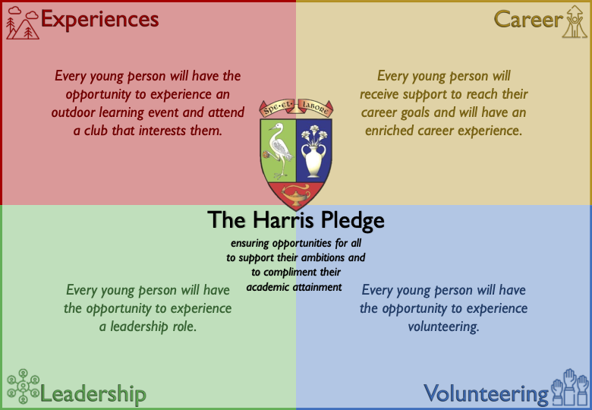
The Harris Pledge is underpinned by each of our values. One of our core values is equality, we work hard to treat everyone fairly regardless of their differences. We do this by ensuring everyone has opportunities to achieve their full potential. In order to deliver this, we have designed the pledge which consists of our commitment to ensure that every young person, regardless of their barriers will be guaranteed the offer of a wide range of experiences.

We have a tracking system to enable data to be shared with all relevant members of staff including information in class sets. This includes 16+ data, volunteering, hobbies, work experience, outdoor experiences, leadership, wider experienced, free meal entitlement and Scottish Index of Multiple Deprivation (SIMD). Opportunities can be targeted; gaps can be identified, and all teaching staff have information about career choice and interests.
Learning Teaching and Assessment
Learning and teaching are key to the realisation of our curriculum offer. Please follow the link to the Harris Academy Standard of Higher Quality Learning, Teaching and Assessment.

Digital skills
Harris Academy has been recognised as a Digital School. This is a national award scheme to promote, recognise and encourage a whole school approach to the use of digital technology in schools. The Harris Standard for digital learning informs us what the expectation is of all, teachers, learners and families. This is supported by our Digital Technologies one stop shop. This provides hints and tips for some of the most commonly used digital technologies in our school. Every young person will have access to a Microsoft Team for every subject area. Our teachers are supported by our Digital CLPL Roadmap, built around feedback from staff, the CLPL roadmap provides a clearly set out plan to approaching the Microsoft Learn online courses. Our Digital stars are members of staff who have volunteered to support colleagues with pieces of software they are comfortable with. Finally, our Digital Leaders, our young people who help share the journey of digital learning and technologies. They are also there to offer a helping hand.
Detailed information can be found in the Harris Academy Digital Technologies pack.

Inter-disciplinary learning (IDL).
All subjects should work collaboratively using inter-disciplinary learning to ensure pupils have a cohesive and meaningful learning experience. Interdisciplinary learning allows pupils to see, make and understand links between discrete subject areas or disciplines.
Effective interdisciplinary learning is a collaborative piece of work, project or course which is planned and coordinated between disciplines, and which delivers one cohesive piece of learning or area of study.
Effective interdisciplinary learning:
- can take the form of individual one-off projects or longer courses of study
- is planned around clear shared purposes
- is based upon experiences and outcomes drawn from different curriculum areas or subjects within them
- ensures progression in skills and in knowledge and understanding across learning
- can provide opportunities for mixed stage learning which is interest-based

Each academic year all S2 young people take part in Youth Philanthropy initiative (YPI). Our young people identify social issues effecting their community and engage with local charities which are working on those social issues through active research and a charities fayre. This includes potential volunteering or fundraising work. Our young people work in groups who compete to win up to £3000 for their chosen charity. Part of the IDL takes place in Modern Studies, English and RMPS. This project is linked to strand C teaching and learning for rights (Rights Respecting Schools) and our young people will complete a level 3 Religion, belief and values award.
Opportunities for collaborative working will be planned within the school calendar and will include the following themes, wider achievement, world of work, health and wellbeing, school show.
This is an area that the school is developing further.

Next Steps

Personal Development
Every young person is entitled to personal support that will enable them to have opportunities to discuss learning with an adult who knows them well and can act as a mentor, helping them to set appropriate goals for the next stages in learning. To facilitate this, we will re-introduce a period of registration daily.
Effective Personal Support will include:
- review of learning and planning next steps
- gaining access to learning activities which will meet their needs
- planning for opportunities for personal achievement
- preparing for changes and choices and support through changes and choices
- working with partners.
Curriculum for Excellence, building the curriculum 3, a framework for learning and teaching.
Following initial discussions with parents/carers and young people we have considered how our existing structure may be developed to provide personal support. The most efficient way for us to implement this will be to move to a 32-period week.

United Nations Convention on the Rights of the Child (UNCRC)
As a nation committed to the United Nations Convention on the Rights of the Child (UNCRC, 1989), Harris Academy are moving towards becoming a fully accredited Rights Respecting School. Harris Academy have been awarded the Silver Award this session (2024).
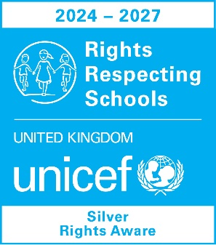
Appendix.
Curriculum Structure 2023/2024
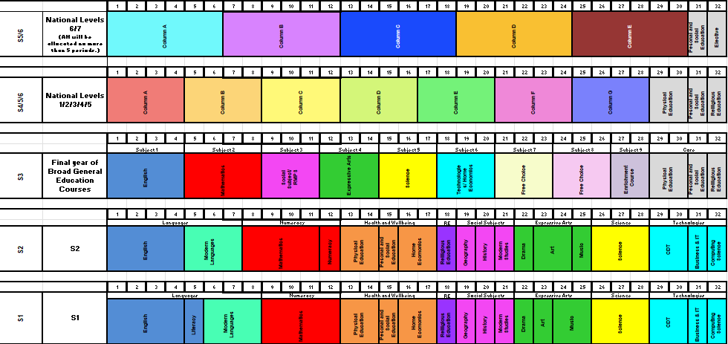
Course choice padlet
Link to our course choice padlet. 2024 Course Choice Information - Harris Academy
This includes course information from subjects based at school, college, Virtual Campus and Consortia (other schools within Dundee).
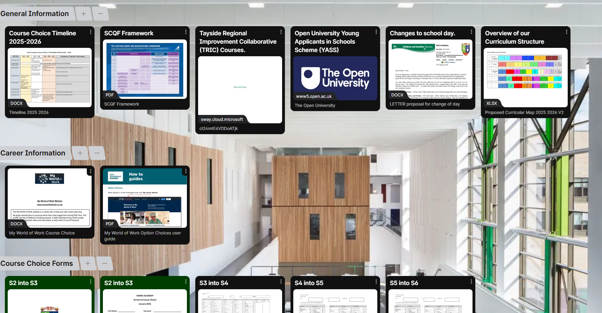
- Tayside Virtual Campus offer: Tayside Virtual Campus 2024 -2025

